**CREATING A VISUALIZATION ABOUT TOTAL DEATH BY COVID – 19 IN STATE WISE:**

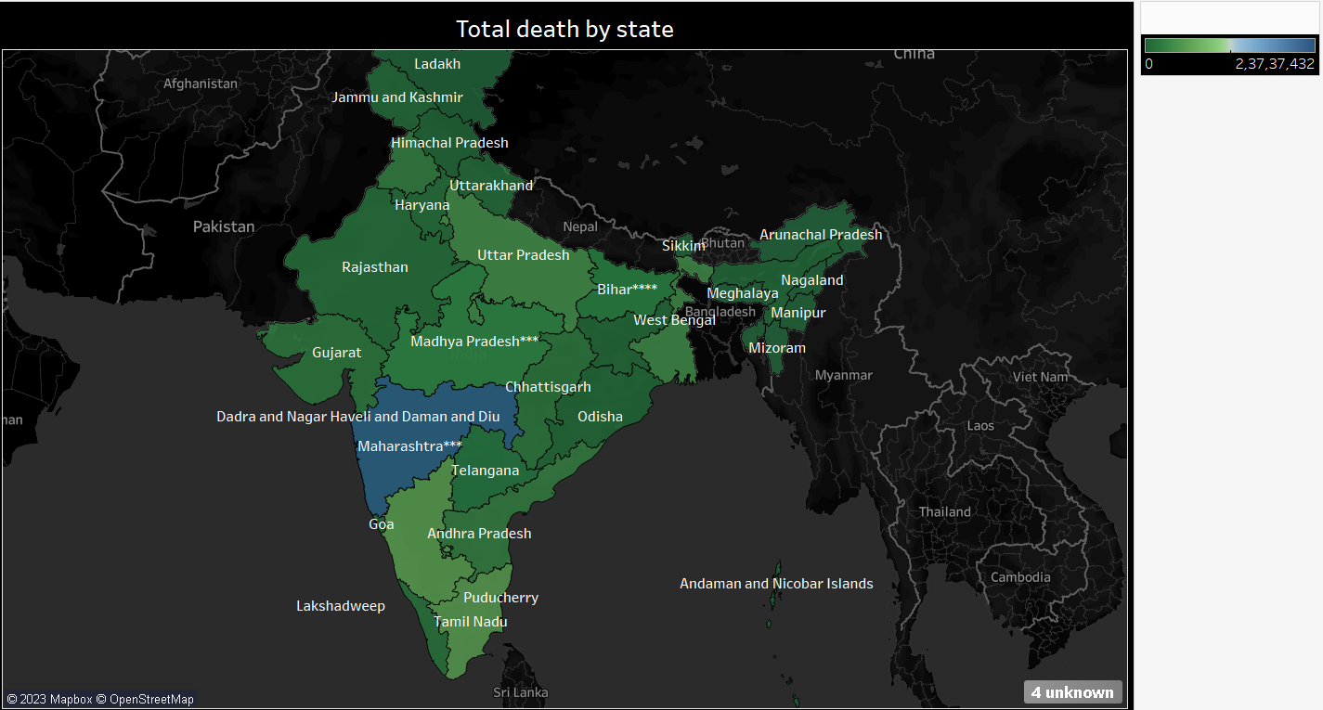

**CREATING A VISUALIZATION ABOUT COVID CASE LIKE CONFORMATION, CURED AND DEATH:**

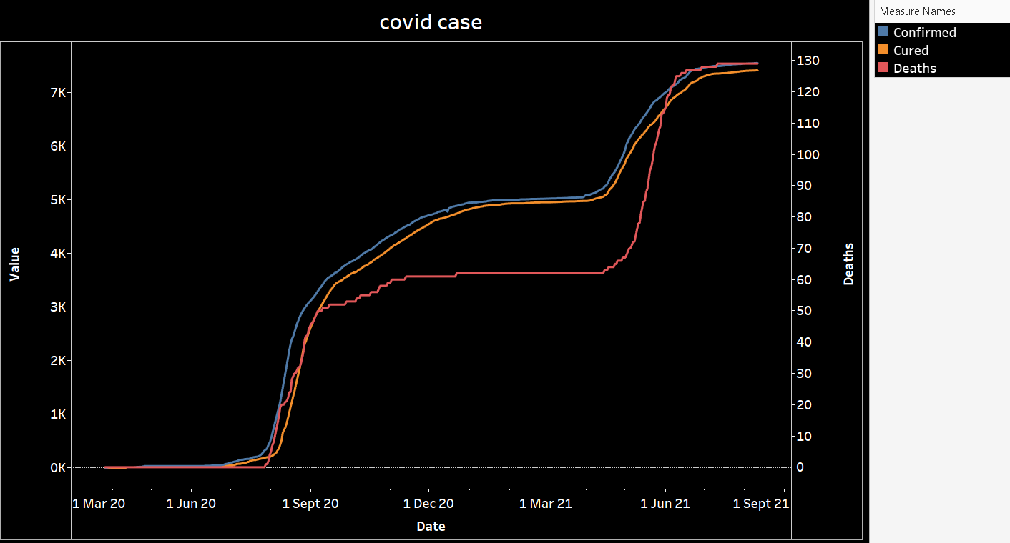

**CREATING A VISUALIZATION ABOUT THE FIRST AND SECOND DOSE ADMINISTRATION IN STATE WISE:**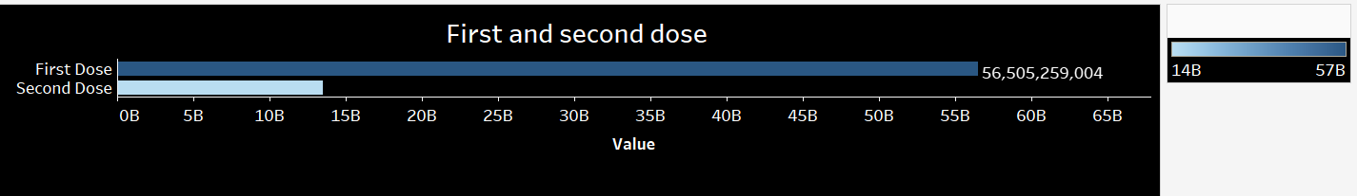

**CREATING A VISUALIZATION ABOUT COVID INFECTED INDIVIDUAL IN EACH GENDER:**

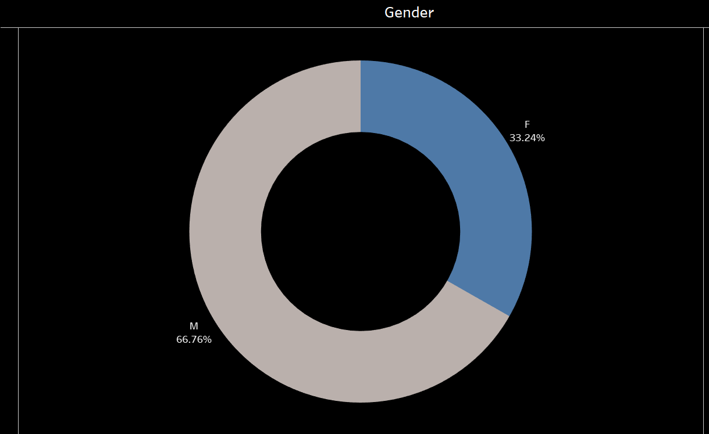

**CREATING A VISUALIZATION ABOUT COVID INFECTED INDIVIDUAL IN AGE-WISE:**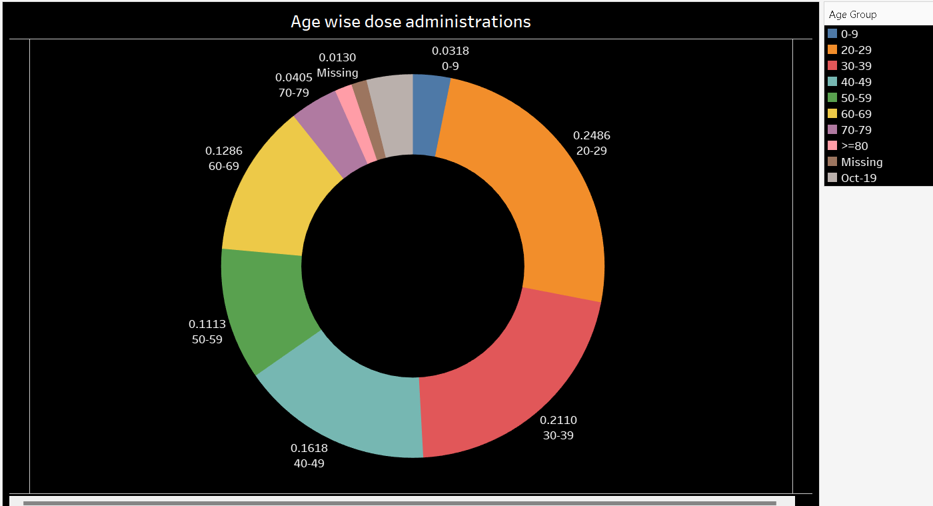

**CREATING A VISUALIZATION ABOUT ICMRT TESTING LABS IN EACH STATE:**

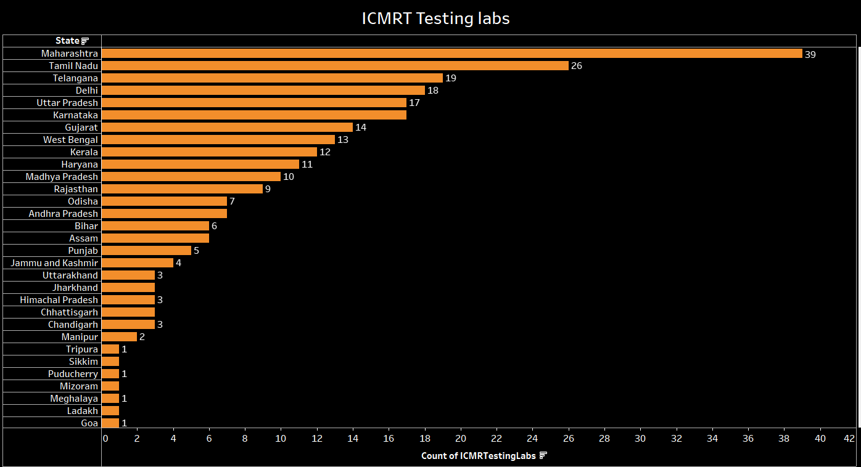

**CREATING A VISUALIZATION ABOUT COVID INFECTED STATE WISE TESTING DETAILS:**

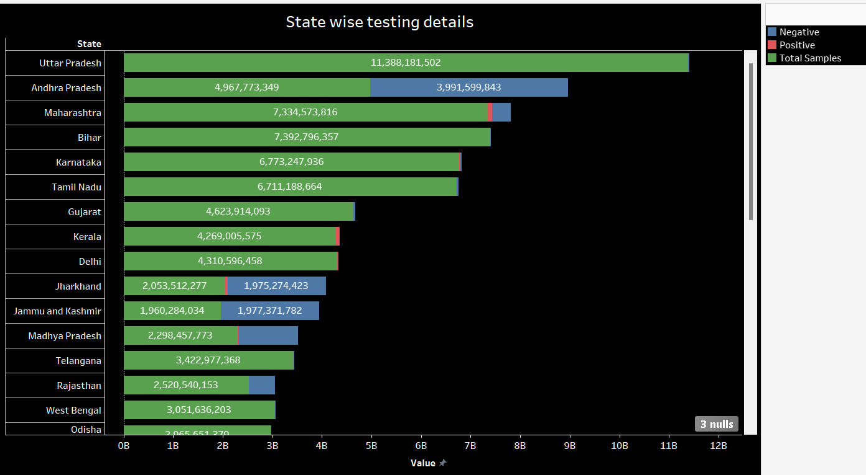

**OUTPUT:**

**DASHBOARD:**

